Median Household Income by State
By: Olivia M. & Elizabeth Scott
Our topic was Median Household Income by State. We wanted to know what people´s income was on average in the United States. We found our data from the census.gov website. Here is our raw data:

State | Income
Alabama | $43,623
Alaska | $72,515
Arizona | $50,255
Arkansas | $41,371
California | $61,818
Colorado | $60,629
Connecticut | $70,331
Delaware | $60,509
Florida | $47,507
Georgia | $49,620
Hawaii | $69,515
Idaho | $47,583
Illinois | $57,574
Indiana | $49,255
Iowa | $53,183
Kansas | $52,205
Kentucky | $43,740
Louisiana | $45,047
Maine | $49,331
Maryland | $74,551
Massachusetts | $68,563
Michigan | $49,576
Minnesota | $61,492
Mississippi | $39,665
Missouri | $48,173
Montana | $47,169
Nebraska | $52,997
Nevada | $51,847
New Hampshire | $66,779
New Jersey | $72,093
New Mexico | $44,963
New York | $59,269
North Carolina | $46,868
North Dakota | $57,181
Ohio | $49,429
Oklahoma | $46,879
Oregon | $51,243
Pennsylvania | $53,599
Rhode Island | $56,852
South Carolina | $45,483
South Dakota | $50,957
Tennessee | $45,219
Texas | $53,207
Utah | $60,727
Vermont | $55,176
Virginia | $65,015
Washington | $61,062
West Virginia | $41,751
Wisconsin | $53,357
Wyoming | $58,840

It didn’t make sense to make a stem and leaf graph based on our data because a stem and leaf shows clusters and our data was widespread. There were no repeats on the same exact number.
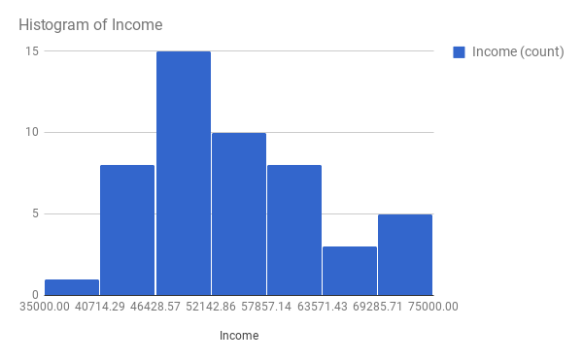
The histogram shows shows a skewed right graph. It showed that between 46428.57 and 52142.86 has the highest income frequency. Between 35000.00 and 40715.29 has the lowest income frequency.

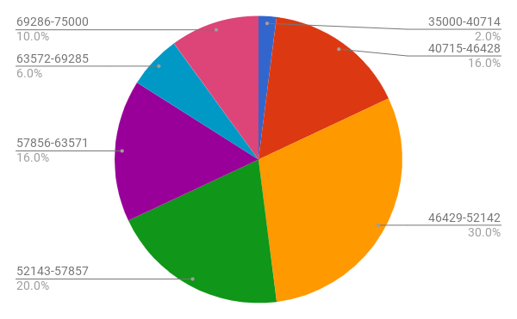
The circle graph showed the percent of each frequency in each class limit. The largest percentage of Median Household Income was thirty percent. The lowest percentage is two percent.

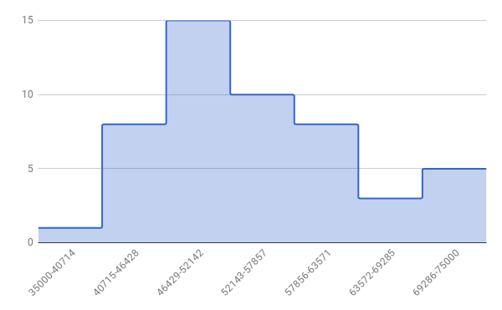The relative frequency also showed a skewed right graph. This graph shows how big of a increase and decrease of income. With the bars all connected it is easy to see the differences.

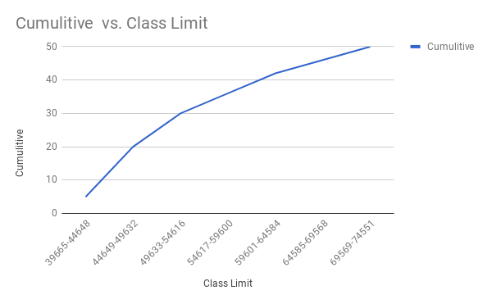
The ogive displayed the cumulative verse the class limit and it showed as the class limits increased so did the cumulative frequency.

Frequency Table:
Class Limit | Boundaries | Frequency | Midpoint | Relative | Cumulitive
39665-44648 | 39664.5-44648.5 | 5 | 42156.5 | 0.1 | 5
44649-49632 | 44648.5-49632.5 | 15 | 47140.5 | 0.3 | 20
49633-54616 | 49632.5-54616.5 | 10 | 52124.5 | 0.2 | 30
54617-59600 | 54616.5-59600.5 | 6 | 57108.5 | 0.12 | 36
59601-64584 | 59600.5-64584.5 | 6 | 62092.5 | 0.12 | 42
64585-69568 | 64584.5-69568.5 | 4 | 67076.5 | 0.08 | 46
69569-74551 | 69568.5-74551.5 | 4 | 72060.5 | 0.08 | 50

The frequency table showed that the highest median income frequency was the class limits between 44649-49632 and the lowest was tied between 64585-69568 and 69569-74551.

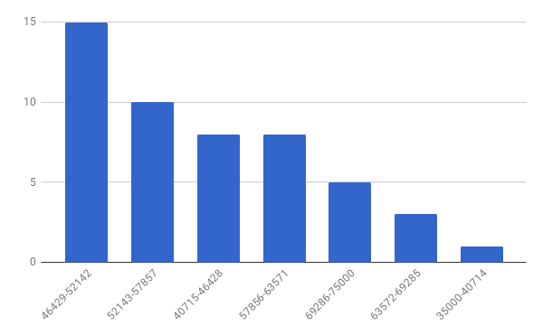
The pareto chart displayed the highest frequency was 15 and the lowest frequency was 1. This graph is easy to read and understand because it goes from greatest median income frequency to the lowest median income frequency from left to right.

The time series graph did not make sense for our data we collected because our data didn’t change over time. We just had data from one specific period.

Our data showed that the median income frequency was the most frequent in the lower half of incomes.

