Probability of Choosing Two Cards from a Deck
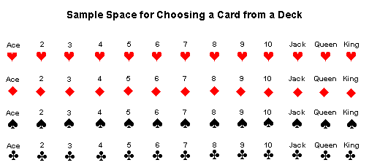

Our raw data was based on a standard deck of cards. We were chosen to draw two cards out of the deck. We made the decision to have the cards replaced after we drew them. Our simple event A was six of hearts. The probability of drawing the six of hearts was 2%. The probability of drawing any card but six of hearts was 98%. Our simple event B was two of clubs. The probability of drawing the two of clubs was also 2%. The probability of drawing any card besides the two of clubs was also 98%. Our events were independent. This means that the two events did not affect each other. The opposite of independent is dependent. This means that they do affect each other. We know that our event is independent because we replaced the card after we drew it. The probability of simple event(A and B) was .00037. We decided to use P(A) times P(B) to calculate this because they were both independent events. This value of .00037 means that would be the probability if we were to pull both cards out at the same time. Our two events were mutually exclusive because they didn’t affect each other since we replaced the cards after we drew them. To find the percent of our two mutually exclusive events we added both of our percents and had the result of 4%. This value of 4% means that we have a 4% chance of drawing both the cards out independently. The multiplication rule of counting means that there’s one way to do one event and another way to do the other event, multiply the events together and that will be the total of both. This rule is used to find the total number of multiple events. An example of using this rule is if I had four choices of bread, five choices of cheese, six choices of meat, and seven choices of dressing. I would multiple four by five by six by seven which would equal a total of eight hundred and forty different choices of sandwiches. Permutation is number of ways to arrange different objects in certain orders. This is used for when order matters to arrange objects. The different methods to calculating permutations are Pn,r=n!(n-r) and nPr. An example of a permutation is the arrangement of all five letters in the word LEWIE in which the two letters E are not next to each other. The total number of arrangements minus number of arrangements with two E next to each other is 5!/2=20.
Combinations is different from permutation by the order does not matter. Combination is the number of combinations of the given objects. This is used for when order doesn’t matter to arrange objects. The methods for calculating combinations are Cn,r=n!/r!(n-r)! or nCr. An example of this is picking a team of three people from a group of ten. 10!x(7!x3!)=10x9x8/(3x2x1)=120.

